PHY691 SBU/CASE - April 18th, 2024

1. Strong focusing synchrotrons, introduction (cont’d)

http://case.physics.stonybrook.edu/images/4/49/SFS_327-364.pdf

2. Longitudinal motion simulations (cont’d)

Carry on with longitudinal motion simulations

3. Your reports: due next by Tuesday 7pm

PHY691 SBU/CASE - April 16th, 2024

1. Strong focusing synchrotrons, introduction

http://case.physics.stonybrook.edu/images/c/c1/IntroSlides_synchrotron_SF_phy691.pdf

http://case.physics.stonybrook.edu/images/4/49/SFS_327-364.pdf

2. Longitudinal motion simulations, cont’d

3. Home work for this Thursday:

- Carry on with longitudinal motion simulations

- Hand in your reports on Thursday, before the class.

PHY691 SBU/CASE - April 9th & 11th, 2024

1. Synchrotron motion simulation exercise:

Status : Zuoheng Yang

2. Synchrotron motion simulation exercise, cont’d:

Plot the theoretical synchrotron tune dependence on energy. Superimpose a few experimental (simulation) values.

Same for theoretical dependence of momentum acceptance on energy.

The synchrotron frequency decreases with dp/p. Compute a few values, including case of motion on separatrix. Give a graph nu_s(dp/p_s), at some E_s of your choice.

3. Start a written report of these simulations.

To be handed back to me next week.

PHY691 SBU/CASE - April 2nd & 4th, 2024

1. Synchrotron motion, theory (FM)

- phase stability, transition gamma (Ref.: Chap. 8.2.2)
http://case.physics.stonybrook.edu/images/a/a2/Synchcrtron_wf.pdf
- longitudinal oscillation, synchrotron tune (Ref.: Chap. 9.2.4)
http://case.physics.stonybrook.edu/images/b/bd/Synch_sf_pp327-362.pdf
- phase space motion, separatrix (Ref.: Chap. 9.2.4)

2. Practical work: simulations (use the course + ZUG)
Use earlier Saturne I lattice. Use CAVITE[IOPT=2] to accelerate, and SCALING to ramp DIPOLE.
A/ Case of stationary bucket: phi_s =0 (or pi if above transition gamma, TBD). Ignore transverse motion: take x, x’, y, y’ all null. In the following, just play with particle momentum, as necessary, using the coordinate D=p/p_0.
A-1/ Calculate the theoretical small-amplitude synchrotron tune at injection energy (3.6 MeV). Verify your finding by simulation of longitudinal motion in phase space (phase, dp/p).
A-2/ Repeat for 3 GeV.
A-3/ From theoretical momentum acceptance, calculate an initial D value that puts a particle on the separatrix.
Using this initial D value, track multiple turns, verify that this generates the separatrix.
B/ Repeat A in the accelerated bucket case - take for instance sin(phi_s)=0.5.
PHY691 SBU/CASE - March 26th & 28th, 2024

Tuesday

1. Acceleration simulations
Volunteer: Sai K.
Summarizes simulations using REBELOTE[IOP=1]

2. Betatron damping, simulations (FM):

- damping of Y(s), Z(s), propto 1/sqrt(p)
- change in ellipse surface, propto 1/p

PHY691 SBU/CASE - March 19th & 21th, 2024

Tuesday

1. Acceleration, no synchrtron motion. Theory (FM)

2. Attack simulation (e) of Ex. 8.1: acceleration

For next week:
- Home work: continue question (e), have status report ready (volunteer: Sai)
- Before the class: send me your written reports, Qs (a)-(d)

PHY691 SBU/CASE - March 19th & 21th, 2024

Tuesday

1. Status report - Tyler
2. Introduction to acceleration

Thursday

1. Introduction to acceleration (cont’d)
- betatron damping
- phase stability / synchronous acceleration

2. Attack question (e) of Ex. 8.1.

For next week:
- Home work: continue question (e), have status report ready (volunteer: Sai)
- Before the class: send me your written reports, Qs (a)-(d)

PHY691 SBU/CASE - March 5th & 7th, 2024

Tuesday

1a. Remarks regarding ex. 3.8 and last week’s reports:
- If you stumble on a contradiction
theory ↔ numerical,
then STOP! Resolve it.

If you do not understand what you are doing, STOP, and THINK. Until theory vs. numerical works.
We want to see well understood results, we’re am not interested by piles of non-sense as I was handed in last week, are we?

- If you are stuck then 1/ discuss among you, 2/ email me, or zoom me, as some of you did.

- Work with high precision numbers, e.g., pi=4*atan(1.), Mp=938.27208MeV, R0=12.924888, etc.

1b. Brief comments regarding the exercise:

The bulk of the physics in the exercise is in what follows, the rest of the exercise was mostly about ode manipulation:

* 200keV => BR=64.62444403717985 kG cm

* We claim this is the reference energy.
Thus it becomes sacred immediately:
B_0R_0 = that BR value

* Then, either decide on B0 value, or on R0 value.

B0=5kG => R0= BR / B0 = 12.92488 cm

R0=50cm => B0= BR / B0 = 1.29248888074 kG

* k=-0.03 is defined at R0: k = k(R0) =
(R0/B0) (dB/dR) :
This is a sacred quantity. It stays at R(200)keV, it is k(200keV). We do not transpose it at R(1MeV), neither at R(5MeV).

As a matter of fact k changes with radius, THIS IS WRITTEN IN Q b) ! It can not be -0.03 at 1MeV neither at 5 MeV neither anywhere but at R0.

This effect is known as the chromaticity: focusing power depends on energy. Same as in photonic optics: lens convergence changes with wavelength.
The focusing power here is the factor of x (or y) in the equation of motion, a k dependent quantity, Eq. 3.15: (1-k)/R0^2 for x motion, or -k/R0^2 for y motion.

2. Hear today’s volunteer: status of work.

(%)
3. Carry on with Saturne 1 synchrotron, ex. 9.1, a-d.
Use your course, use your Users’ Guide.

- Home work for Thursday

Carry on with Saturne 1 synchrotron, ex. 9.1, a-d.

PHY691 SBU/CASE - Feb 27th & 29th, 2024

- Tuesday

1. Hand in your reports / ex. 3.8

2. Reminder:
beam ellipse,
beam matrix and its transport,
beam envelop

3. An introduction to the synchrotron accelerator – weak focusing

- Home work for Thursday

Start building Saturne 1 synchrotron, ex. 9.1, a, b

PHY691 SBU/CASE - Feb 20th & 22nd, 2024

- Tuesday: Carry on with exercise 3.8

- Home work for Thursday: same

- Thursday: Carry on with exercise 3.8

- Next Tuesday: hand me in your latex/.pdf report.
Use previous “Solution” document I gave you, as a guidance for writing down your report.

PHY691 SBU/CASE - Feb 13th & 15th, 2024

Tue. 13th
  - Classes canceled by SBU
  - Complete ex. 3.2 and 3.3. Reports expected by 8:20pm.

Thu. 15th
1/ Discuss exercises 3.2 and 3.3 to make sure we fully understand the basics of the software

2/ Start exercise 3.8
http://case.physics.stonybrook.edu/images/1/18/Cyclo_classical_71-95.pdf

This exercise is about
  - simulating transverse ion motion in a cyclotron, including weak transverse focusing (-1<k<0, Eqs. 3.11-12);
  - checking horizontal x(s) and vertical y(s) motion components, against theory (Eqs. 3.16-17);
  - checking the number of horizontal and vertical oscillations per revolution, ν_{x} and ν_{y}, against theory (“wave numbers”, Eqs. 3.18-9)
Question (d) is about cos(2πν_{x,y}) = ½ Trace [T_{x,y}]
where [T_{x,y}] = 2x2 horizontal or vertical 1-turn matrix
See reminder, Sect. 13.5.2 and Eq. 13.57 in
http://case.physics.stonybrook.edu/images/8/89/Pp305-326_complements.pdf

3/ Home work for next Tuesday:
- Continue exercise 3.8.
- Need a volunteer at start of class: status slides (15~20 min)
PHY691 SBU/CASE - Feb 6th & 8th, 2024

Tue. 6th
  - 7pm (a volunteer 15~20 min.)
    - show her/his progress. Scrolling down your report is fine, dedicated slides are not necessary.
    - Questions/discussion (all)

  - 7:20 - 8:20 (you)
    - advance/complete exercise 3.2
and its report - latex (or clean python nb, if it allows showing equations)

Thu. 8th
  - 7:00pm (you)
    - we're done with ex. 3.2. You hand me back your reports.
  - 7:05 (me, 15min)
    - theory: weak focusing, transverse motion along the orbits
  - 7:20 - 8:20 (you)
    - start exercise #3.3, a-d: resonant acceleration; beam monitoring with FAISTORE
Some one can help?

We are 8, I see 5 names below.

Missing attendees are

Sai Sumanth Kantamneni
Siddhant Mehrotra
Song Ye Liang

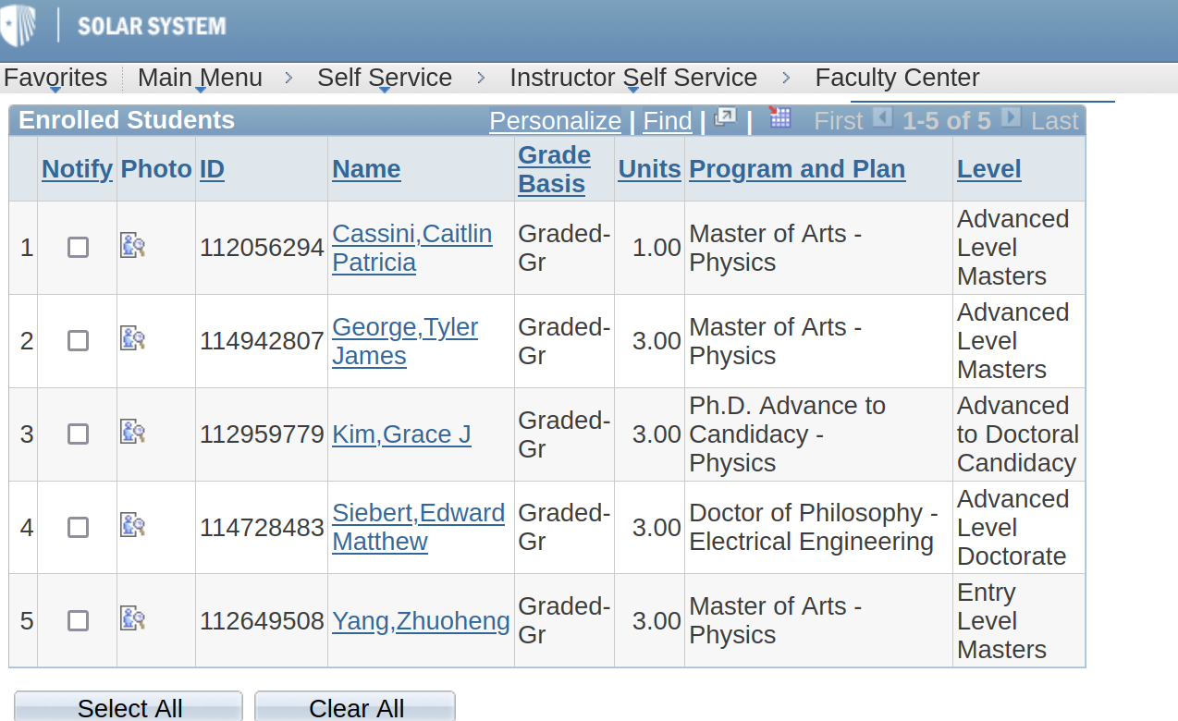
Best to sign up at Phys & Astro Department

PHY691 SBU/CA
SE - Thu Feb 1st, 2024

1/ Info:

A Zoom-meeting link is available until May, see your emails.

May be used during the week as needed when/if questions.

2/ Carry on with exercise 3.2, Classical Cyclotron.

Theory: use documentation provided on CASE site, e.g.

http://case.physics.stonybrook.edu/images/1/18/Cyclo_classical_71-95.pdf

Programming: use the Users’ Guide

http://case.physics.stonybrook.edu/images/5/5c/Zgoubi_2024.pdf

3/ Home work for next Tue: complete ex. 3.2, a-d.

PHY691 SBU/CASE - Tue Jan. 30, 2024

1/ Plans

1.a ? Did you read, as instructed,

http://case.physics.stonybrook.edu/images/1/14/TechIntro_26-34.pdf

Hopefully. If not, do so

1.b We start lab work today. Lab work reports:

* For each simulation exercise, end me back a .pdf
- Latex strongly recommended
- I want to see the equations and their numerical outcomes (hence latex, as opposed to time-wasting .doc), by which you justify and explain the outcomes of your numerical simulations
- Produce graphs comparing simulations with theory

* End me back this .pdf report asap:
- yes, this means home work in prospect
- and yes, at some point there may be a deadline to hand it back

* ONE report each one of you, or each team of 2 if any
- No two similar reports.
- Please work simulations on your own, based on your own working methods, and on your own understanding of the physics behind.
- I encourage discussions during the class

2. Classical Cyclotron, theory, reminder (me, ~15 min):

http://case.physics.stonybrook.edu/images/1/18/Cyclo_classical_71-95.pdf

3. Lab work (you):

Exercise #3.2 in that document

4. Home work for this Thursday:

- Carry on with lab. work.

- If you’re done with this exercise and writing down your report by Thursday, end it back to me.

- You’re stuck? Email me!

PHY691 SBU/CASE - Tue Jan. 23, 2024
INTRODUCTION TO THIS COURSE

1. Presentations. Schedule

- François Méot
Accelerator physicist
Brookhaven National Lab, Collider-Accelerator Department

Caitlin Cassini /M
Tyler George /M
Song Lyang /D
Siddhant Mehrotra /M
Edward Siebert /D
Zhuoheng Yang /M

- Tue, Th, 7:00-8:20pm
Do we really want that? Can we move earlier?

2. CASE web site. Plans for the coming weeks

http://case.physics.stonybrook.edu/index.php/PHY691_spring_2023#Course_Schedule

3. We’ll use zgoubi for our beam simulations

- grab zgoubi package from sourceforge:

Browse ‘sourceforge zgoubi’; go to ‘Code’; once there go to trunk; on the upper bar there “Download snapshop”; unzip zgoubi-code-blahblah.zip.

There you are.

- in zgoubi-code folder: ‘make’ to compile. The resulting executable is
[pathTo]/zgoubi-code/zgoubi/zgoubi

- test your installation – see below

4. Home work for Thu 25 Jan

1/ Complete zgoubi installation as needed, so to eventually obtained the executable, namely,
[pathTo]/zgoubi-code/zgoubi/zgoubi

2/ Test your installation

For this test, use the file 60degSector_MATRIX.inc found in

https://sourceforge.net/p/zgoubi/code/HEAD/tree/branches/exemples/cyclotron/classical/360DegreeSector_usingDIPOLE/six60degSectors/

Namely, just run it, like so:

[pathTo]/zgoubi-code/zgoubi/zgoubi -in 60degSector_MATRIX.inc

Inspecting the content of 60degSector_MATRIX.inc and of zgoubi.res:

(i) convince yourself that the run worked properly,
(ii) figure out what zgoubi does from top to bottom of 60degSector_MATRIX.inc,
(iii) check that this simulation of a 60 degree sector dipole produces results.

3/ In zgoubi Users’ Guide: [pathTo]/zgoubi-code/guide/Zgoubi.pdf

read pp. 23-24 about zgoubi numerical integrator.

4/ Read "Beam Optics: Simulation Method” [Day 1 on CASE page].

Expected results from the installation test
[pathTo]/zgoubi-code/zgoubi/zgoubi -in 60degSector_MATRIX.inc

Use the document
Beam Optics, Complements
found at the bottom of CASE/PHY 691 page.

At the bottom of zgoubi.res, we find that the 6x6 coordinate transport matrix of the 60 degree magnetic sector is

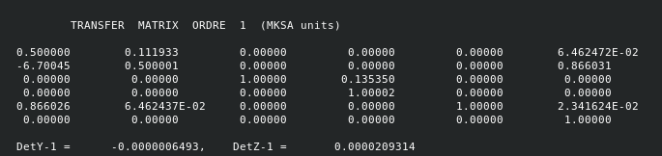
Expected values are,

- horizontal 2x2 transport matrix:
R₁₁=cos α = cos (60 deg) = 0.5,
R₁₂ = R sin α = 12.92488 sin (60 deg) = 11.19327 cm,

- vertical, just a drift of length L= R α, thus a 2x2 drift matrix, i.e.
R₃₃ = R₄₄ = 1
R₃₄ = L = R α = 12.92488 * pi*60/180=13.5349 cm

- dispersion terms:
R₁₆ = R (1 – cos α) = 12.92488 (1 - cos (60 deg)) = ).5*R = 6.46244 cm
R₂₆ = sin α = sin (60 deg) = 0.8660

